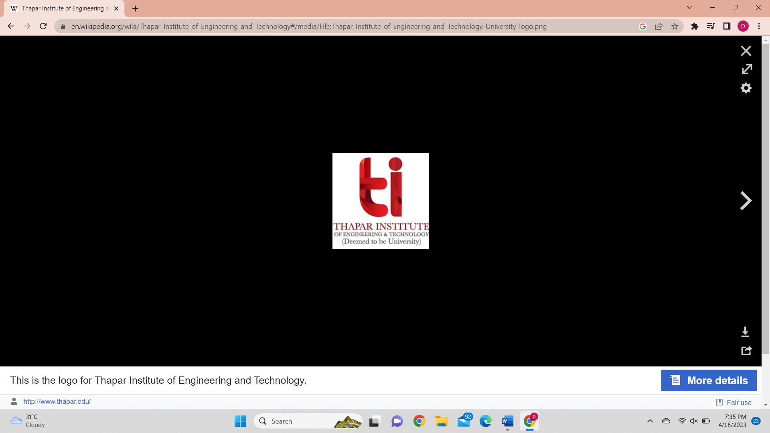

**Artificial Intelligence**

**Lab project submission**

**Submitted to:** Dr. Varun

**Submitted by:**

Akshay Garg-102116048

Divya Arora-102116033

Nikhil-102116061

Pushkar-102116043

**Problem statement:**

Python Flask web application that analyzes the emotions and sentiment of a text input like sadness ,anger ,jealousy happiness etc. and returns whether the paragraph shows positive sentiments, negative sentiments or neutral sentiments.

**Description of problem:**

Sentiment analysis involves analyzing text to determine the emotional tone of the communication. It involves the use of natural language processing (NLP) techniques to extract and classify opinions, attitudes, and emotions expressed in text. It is used in social media monitoring to track public opinion about a brand, product, or service. Sentiment analysis is also used in market research to gain insights into consumer behavior and preferences. Overall, sentiment analysis is a valuable tool for businesses and organizations to gain insights into customer behavior and preferences, improve customer satisfaction, and make informed decisions.

**Survey paper:**

Here is a brief survey of 5 papers related to sentiment analysis:

* "Sentiment Analysis: A Review" by Bing Liu (2012): This paper provides an overview of the field of sentiment analysis, including its history, approaches, and applications. It also discusses the challenges of sentiment analysis, such as dealing with sarcasm and irony. "Deep Learning for Sentiment Analysis: A Survey" by Lei Zhang et al. (2018): This paper surveys the use of deep learning techniques for sentiment analysis. It covers various models and approaches, including convolutional neural networks (CNNs), recurrent neural networks (RNNs), and attention mechanisms.
* "Sentiment Analysis and Opinion Mining" by Bo Pang and Lillian Lee (2008): This paper discusses the challenges of sentiment analysis and presents a comprehensive framework for analyzing opinions and sentiments in text. The framework includes techniques for identifying the subjectivity and polarity of text, as well as methods for extracting and summarizing opinions.
* "Aspect-Based Sentiment Analysis" by Donghui Zhang et al. (2020): This paper focuses on aspect-based sentiment analysis, which involves identifying the specific aspects or features of a product or service that are being discussed in text and analyzing the sentiment towards each aspect. The paper presents a deep learning-based model for aspect-based sentiment analysis and evaluates its performance on several datasets.
* "Sentiment Analysis in Social Media" by Stefano Baccianella et al. (2010): This paper focuses on sentiment analysis in social media, which presents unique challenges due to the informal nature of social media text and the prevalence of noise and spam. The paper discusses various approaches for sentiment analysis in social media, including lexicon-based and machine learning-based methods, and provides an evaluation of their performance on several datasets.

**Directory structure:**

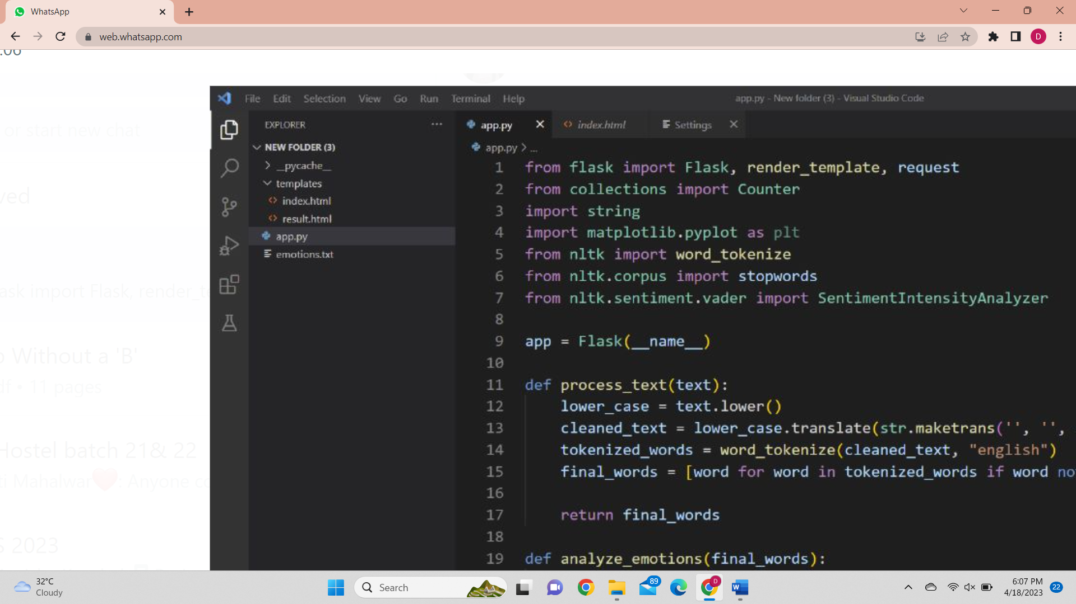

**IMPORTING USED MODULES**

Brief description of the imported modules:

1. **string:** The string module in Python provides a collection of useful constants and functions that are related to string manipulation
2. **Pandas:** Pandas is a popular data analysis and manipulation library in Python that provides easy-to-use data structures and data analysis tools for processing and analyzing structured data.
3. **Natural language toolkit:** The Natural Language Toolkit (NLTK) is a Python programming environment for creating applications for statistical natural language processing (NLP). For tokenization, parsing, classification, stemming, tagging, and semantic reasoning, it includes text processing libraries.
4. **Collections package:** Counter library present inside collections package is used to count the number of emotions that are being entered inside our read.txt file.
5. **Flask:** Flask is a popular Python web framework that allows developers to create web applications quickly and easily. It's a lightweight framework that provides a lot of flexibility.

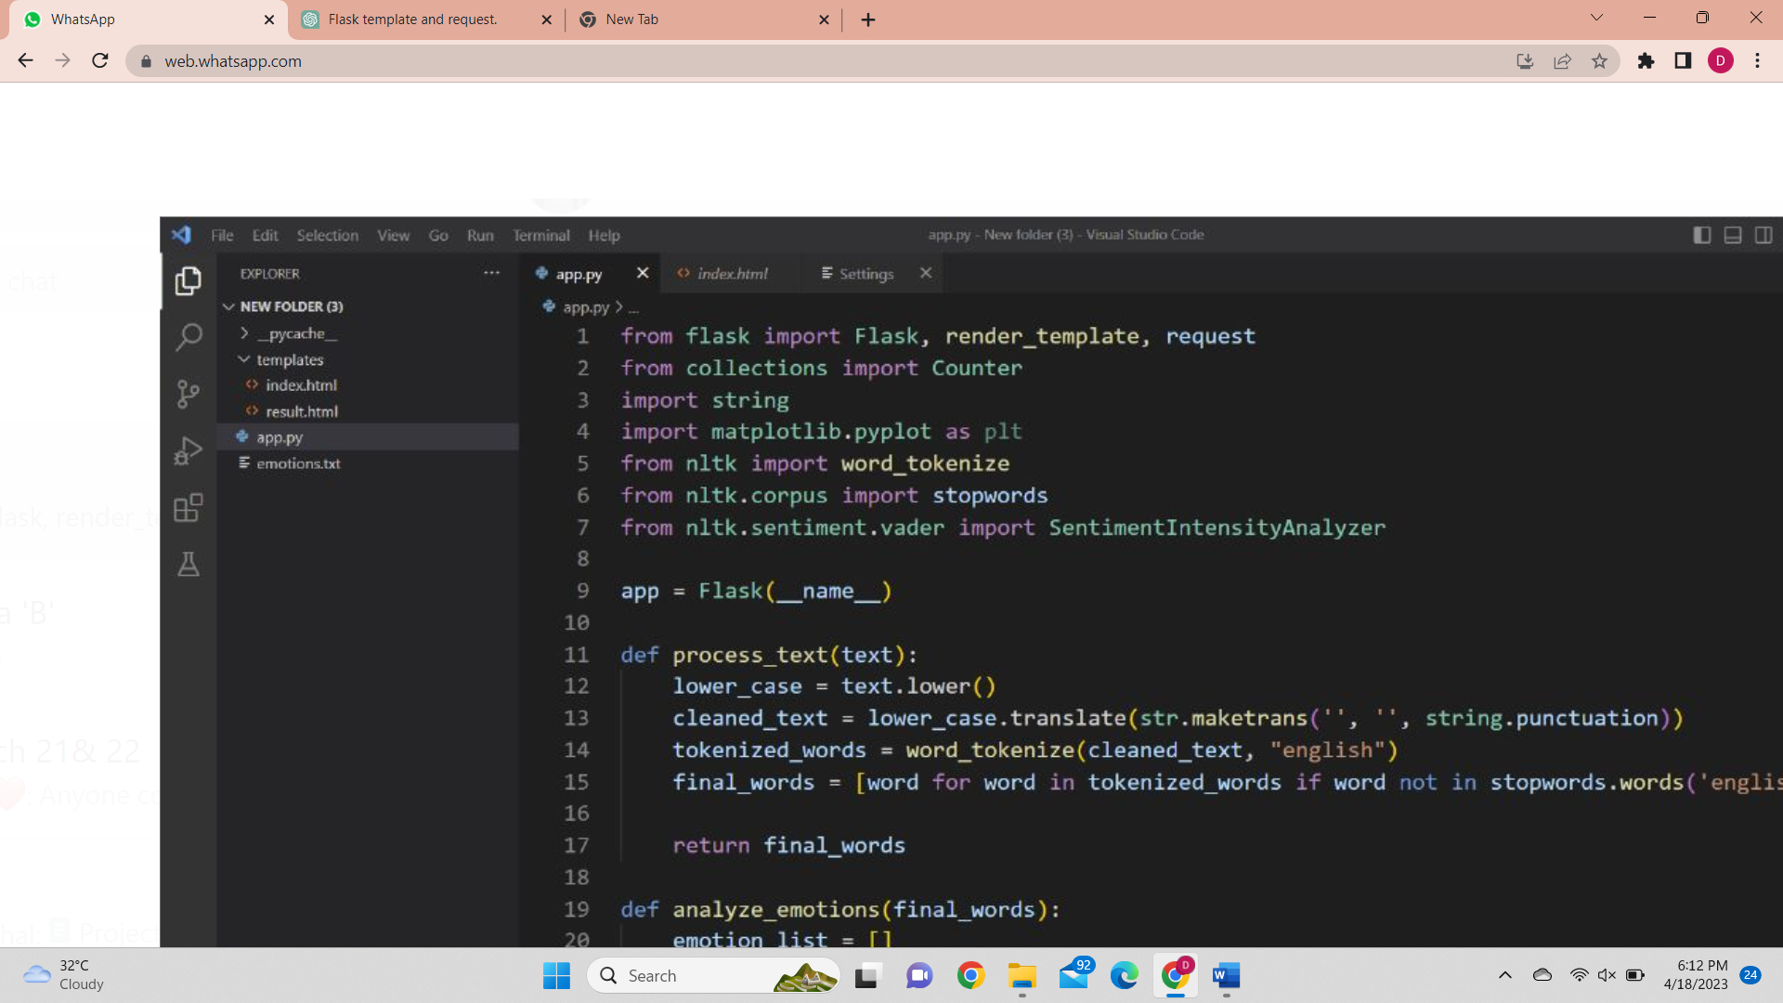

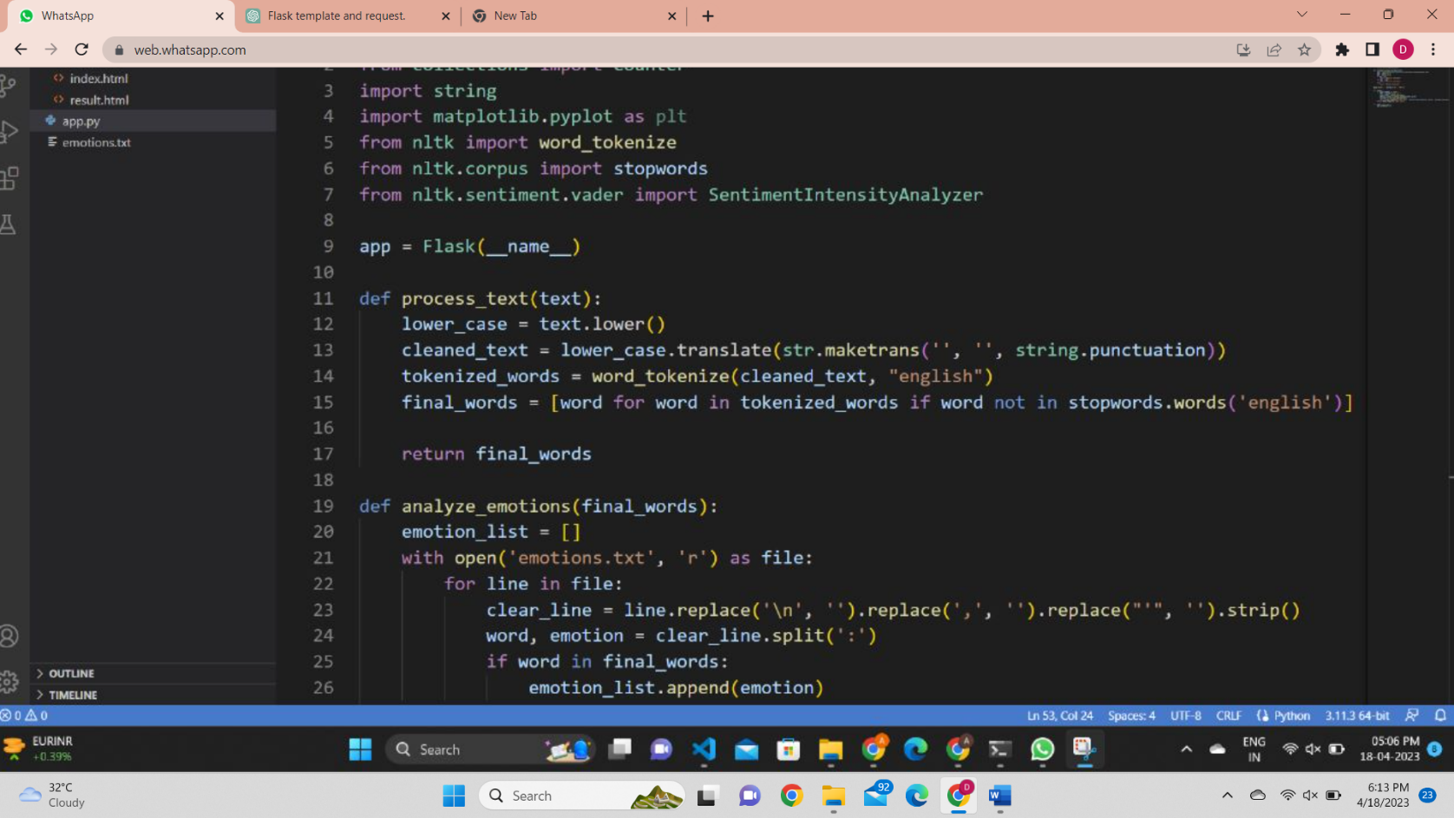

This text is converted to lower case and all the punctuations are removed using the above function that contains all the default punctuation symbols inside it. The process_text function takes a text parameter, which is a string that represents some input text. The purpose of this function is to process the input text and return a list of "final words" that have been cleaned and pre-processed for further analysis.

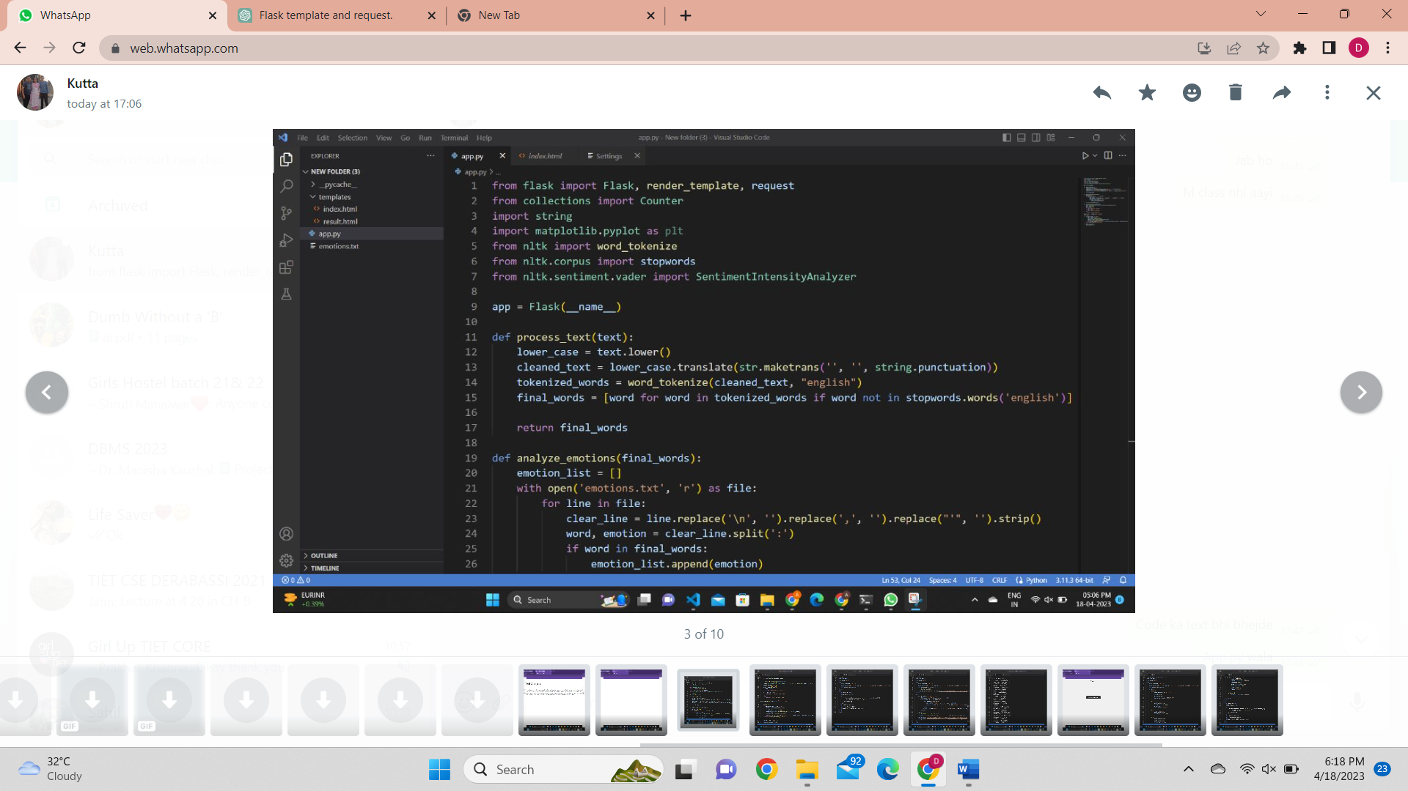

The analyze_emotions function takes a list of "final words" as input, and uses it to perform an emotion analysis on the text. The function reads in a text file (emotions.txt) that contains a list of words and their associated emotions, and then checks whether each word in the input list is present in the emotion file. If a word is found in the emotion file, its associated emotion is added to a list of emotions (emotion_list). Finally, the function returns a Counter object that counts the frequency of each emotion in the emotion_list

Overall, this analyze_emotions function provides a simple way to perform emotion analysis on a text by using a pre-defined emotion lexicon (emotions.txt). The resulting Counter object provides a convenient way to summarize the distribution of emotions in the input text.

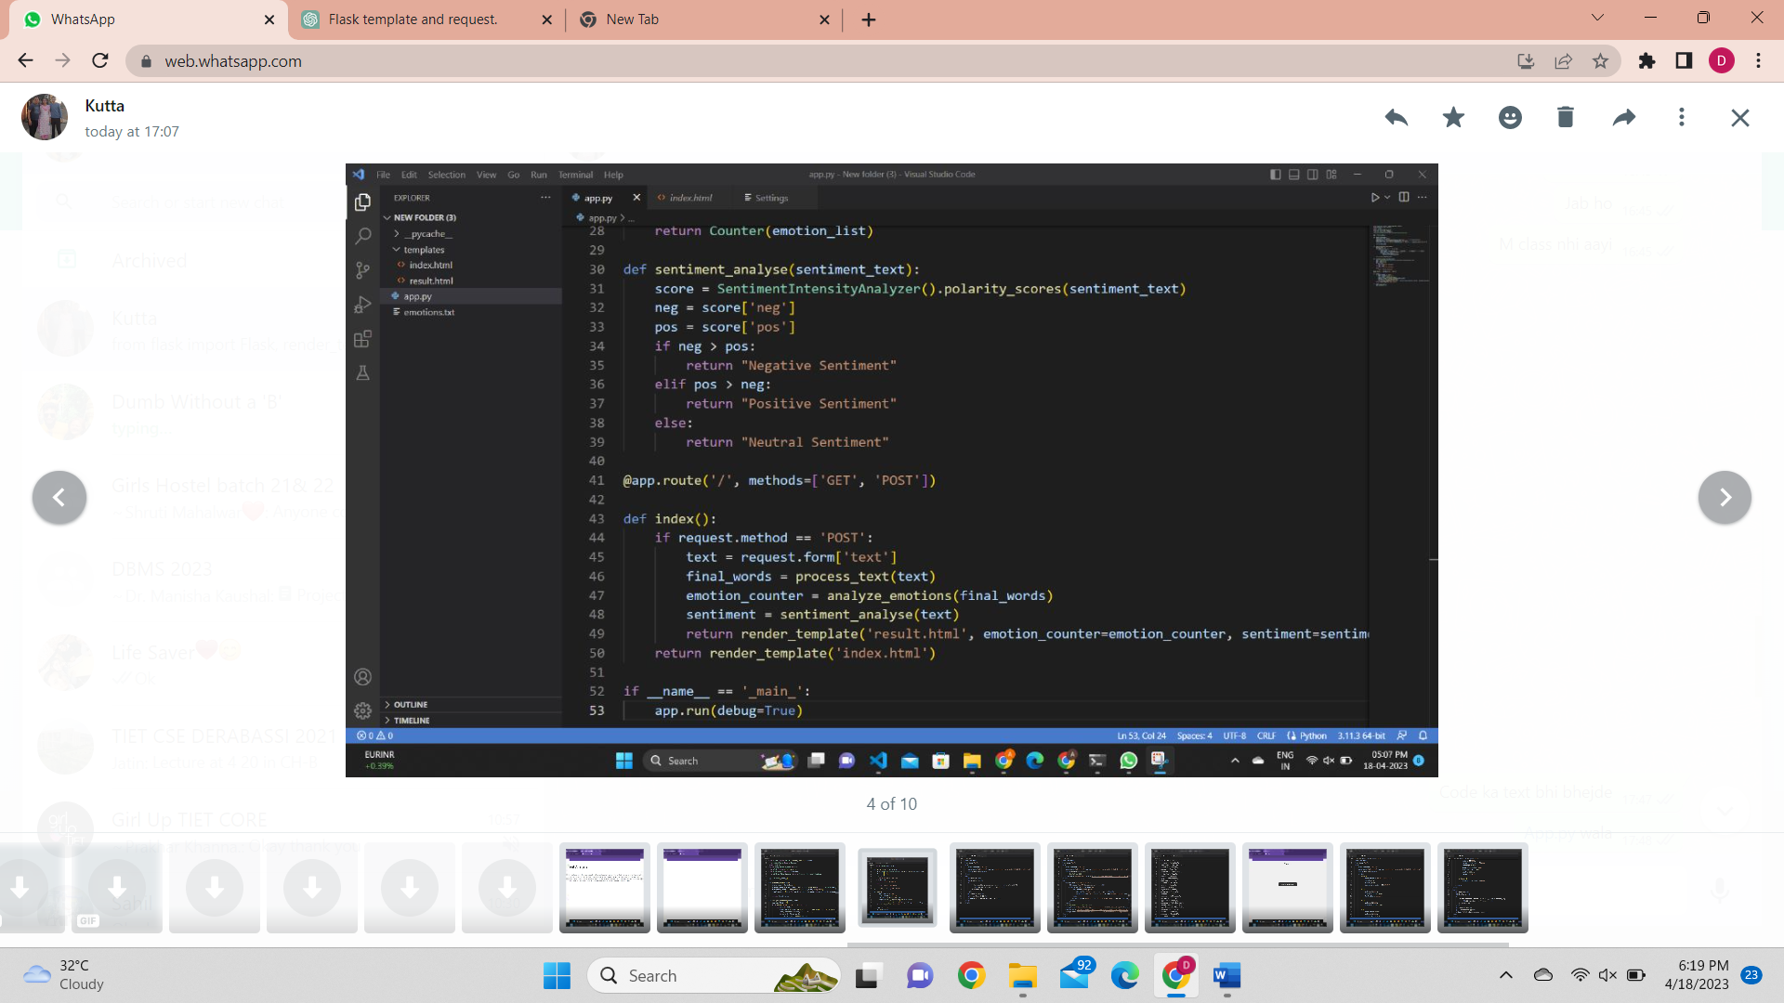

The sentiment_analyse function takes a string of text as input (sentiment_text) and uses the SentimentIntensityAnalyzer class from the nltk.sentiment.vader module to perform sentiment analysis on the text. This function returns a string indicating the overall sentiment of the input text as "Positive Sentiment", "Negative Sentiment", or "Neutral Sentiment".

SentimentIntensityAnalyzer() in NLTK uses the VADER (Valence Aware Dictionary and sEntiment Reasoner) lexicon to determine the sentiment intensity of text. The VADER lexicon is a pre-built sentiment lexicon that contains over 7,500 lexical features such as words, emoticons, and slang with associated sentiment scores ranging from -1 (most negative) to +1 (most positive).

VADER is specifically designed to analyze sentiment in social media texts, which can be more challenging due to their informal language, use of slang, and presence of sarcasm and irony. VADER uses a set of rules and heuristics to interpret the sentiment of social media text, including features like capitalization, punctuation, and degree modifiers (e.g., "very" or "extremely").

A lexicon is a vocabulary or a set of words, phrases, or other linguistic units that are associated with specific meanings, concepts, or categories. In natural language processing (NLP), a lexicon typically refers to a collection of words or phrases that are used to analyze the sentiment, emotion, or other linguistic features of text.

In sentiment analysis, for example, a lexicon-based approach involves using a pre-built sentiment lexicon that contains a list of words or phrases with associated sentiment scores to determine the overall sentiment of a piece of text. Each word in the lexicon is assigned a polarity score, which indicates its positive or negative sentiment. When a sentiment analysis tool encounters a word or phrase from the lexicon in the text, it assigns the corresponding sentiment score to the text, and the sentiment scores are aggregated to determine the overall sentiment polarity of the text.

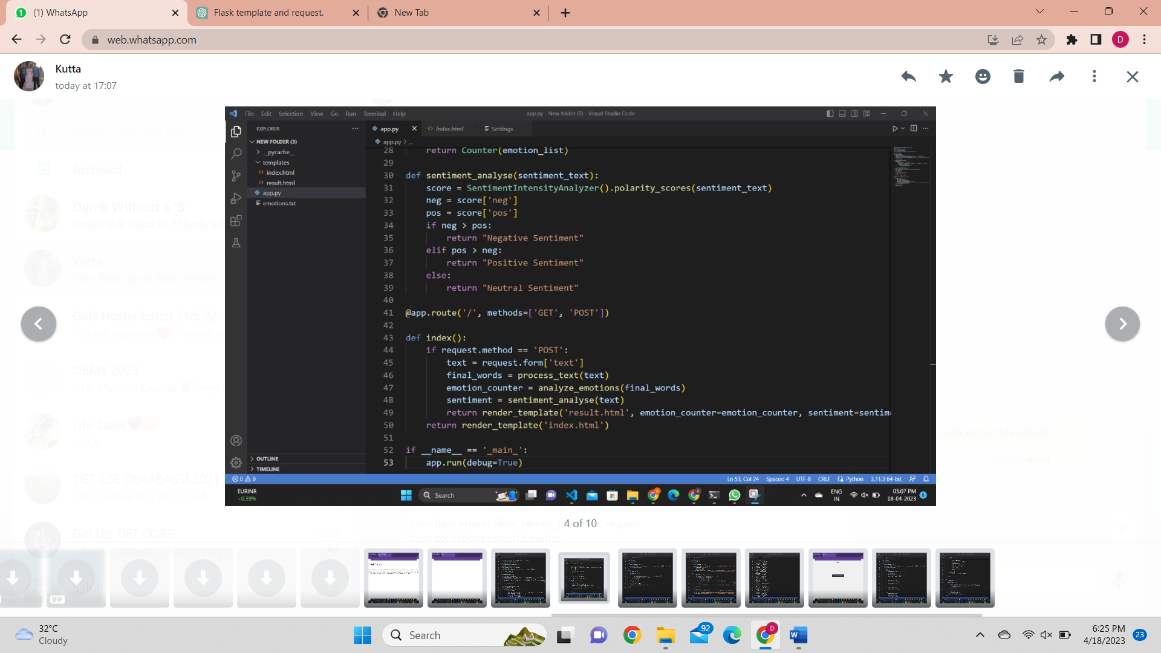

This code defines a Flask application with two routes - the root route ('/') and a result route ('/result'). The root route ('/') serves an HTML form for users to enter text, while the result route ('/result') displays the results of sentiment and emotion analysis on the text entered by the user. Overall, this code provides a simple web interface for users to perform sentiment and emotion analysis on their text inputs. The process_text, analyze_emotions, and sentiment_analyse functions are called to preprocess the text and extract relevant features, which are then displayed to the user using the render_template function.

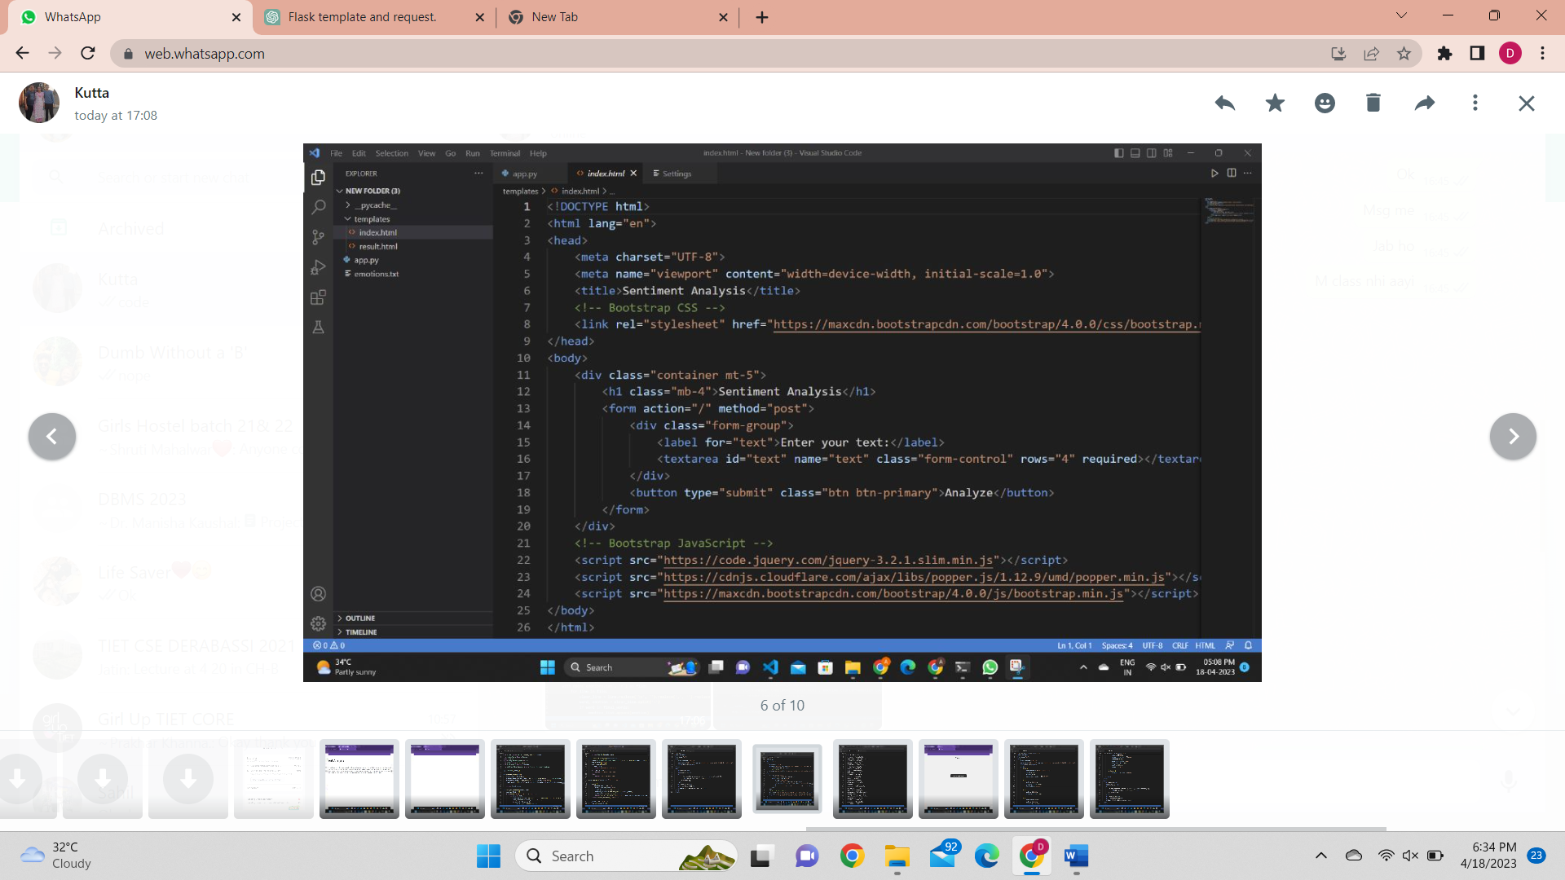

This is an HTML code for a simple web page that allows users to input a text and perform sentiment analysis. The code begins with the standard HTML5 doctype declaration, followed by an opening html tag with the "lang" attribute set to "en" to specify the language of the document. In the head section, there are a few meta tags that define the character encoding and the viewport. The title tag sets the title of the page to "Sentiment Analysis". The next line links to a Bootstrap CSS stylesheet that will be used to style the web page. The body section contains the content of the web page. The content is wrapped in a container div with a top margin of 5. The h1 tag displays the heading "Sentiment Analysis". The form tag contains a text area input field with the label "Enter your text:". The name of the field is "text" and is required. The form also contains a submit button with the label "Analyze". Finally, the web page uses jQuery and Bootstrap JavaScript libraries to enhance the user interface and make the web page more interactive.

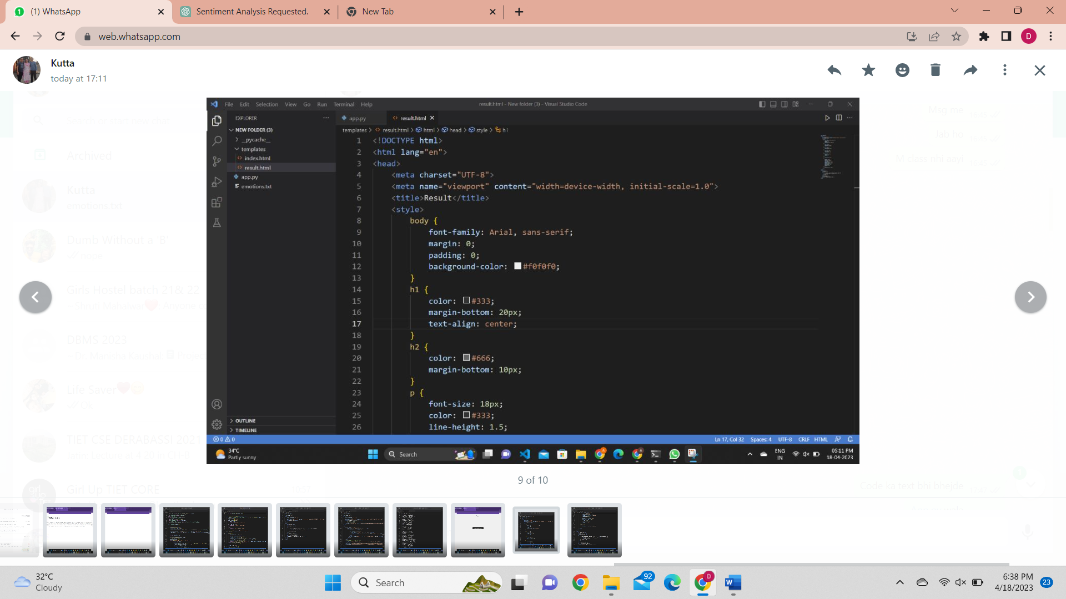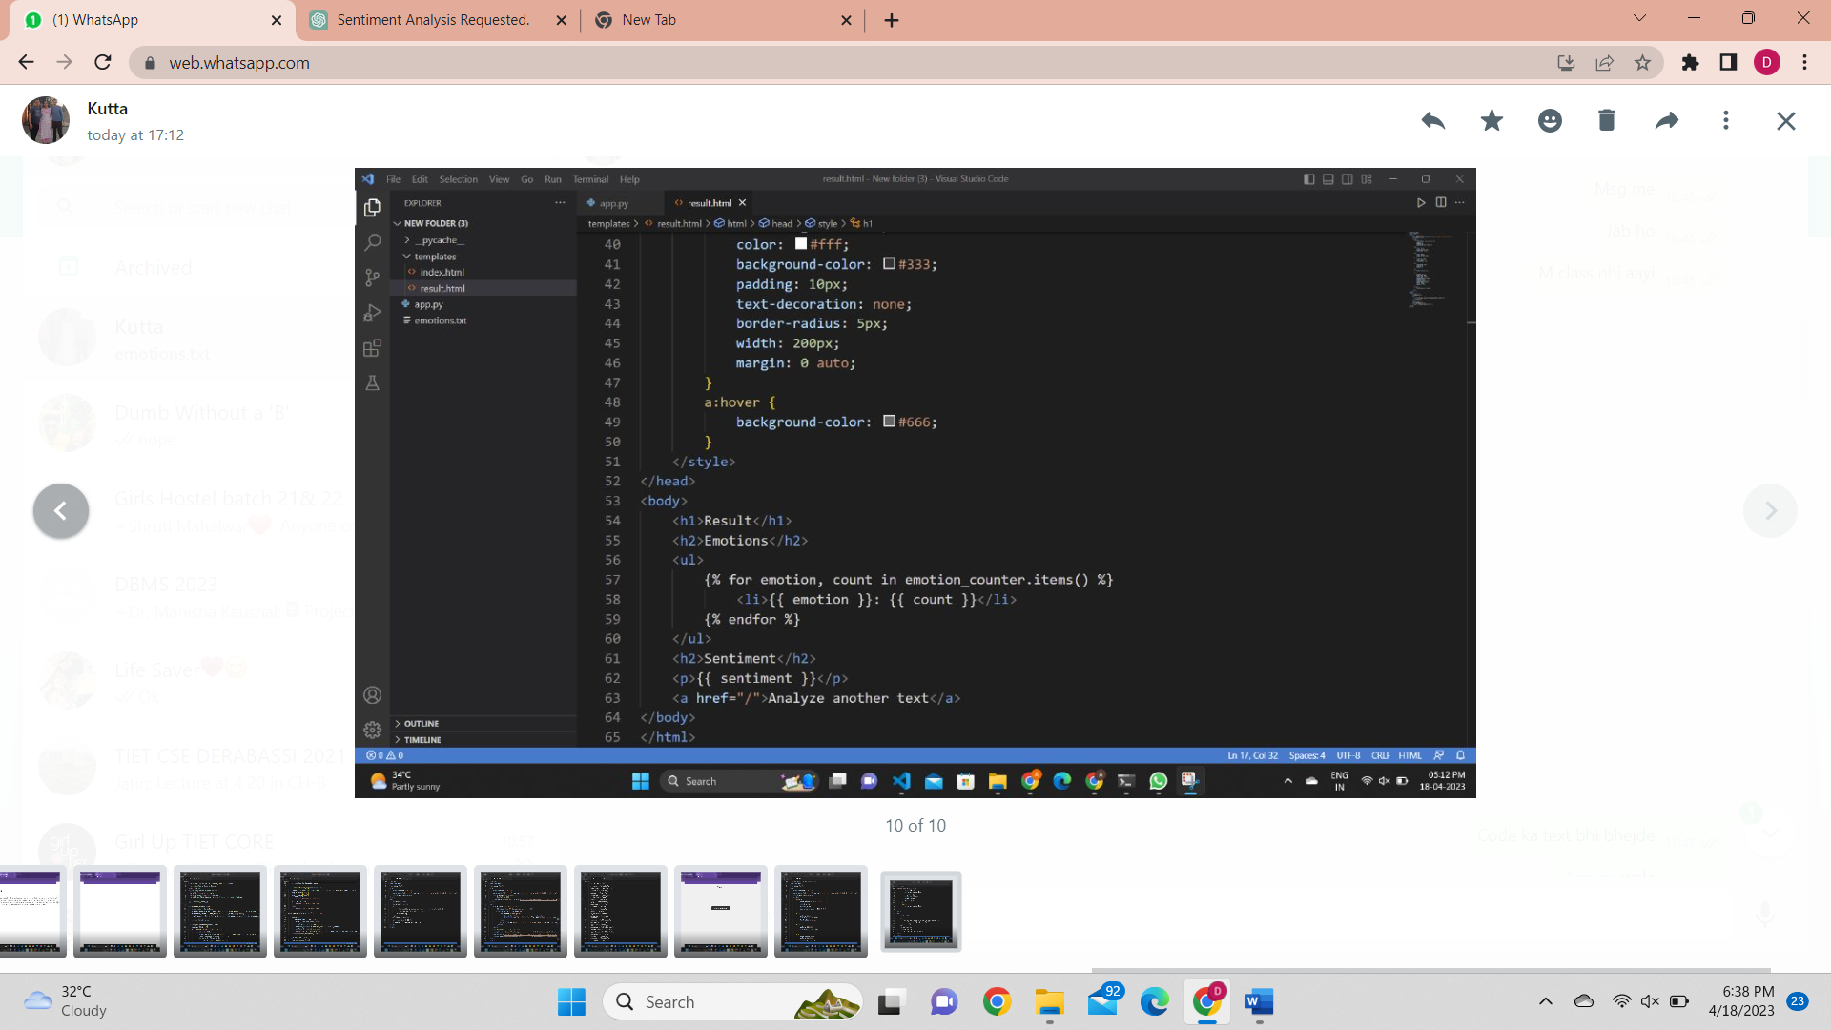

This is an HTML code for a result page after the sentiment analysis is performed on a given text. The code starts with the standard HTML5 doctype declaration, followed by an opening html tag with the "lang" attribute set to "en" to specify the language of the document. In the head section, there is some CSS styling to format the appearance of the result page. In the body section, the content of the result page is displayed. The h1 tag displays the heading "Result". The h2 tag displays the heading "Emotions" and is followed by an unordered list that contains the emotions and their corresponding counts as key-value pairs. The emotions and their counts are displayed using a for loop and variables named "emotion" and "count", respectively. The h2 tag displays the heading "Sentiment" and is followed by a paragraph tag that displays the sentiment of the text. Finally, an anchor tag with the label "Analyze another text" is displayed at the bottom of the page. When clicked, the user will be redirected to the analysis page

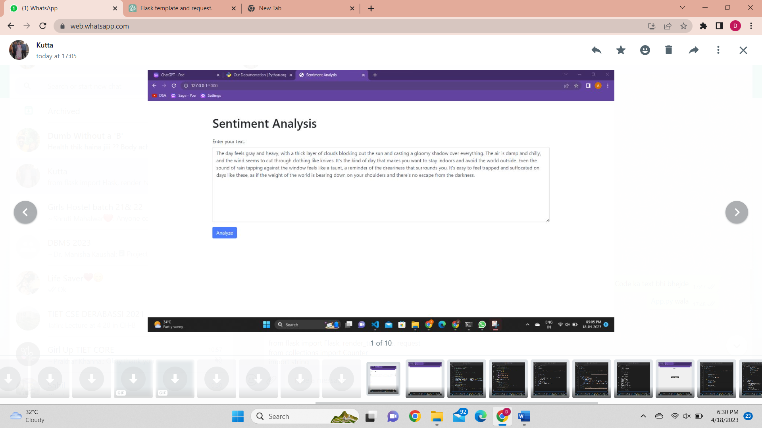

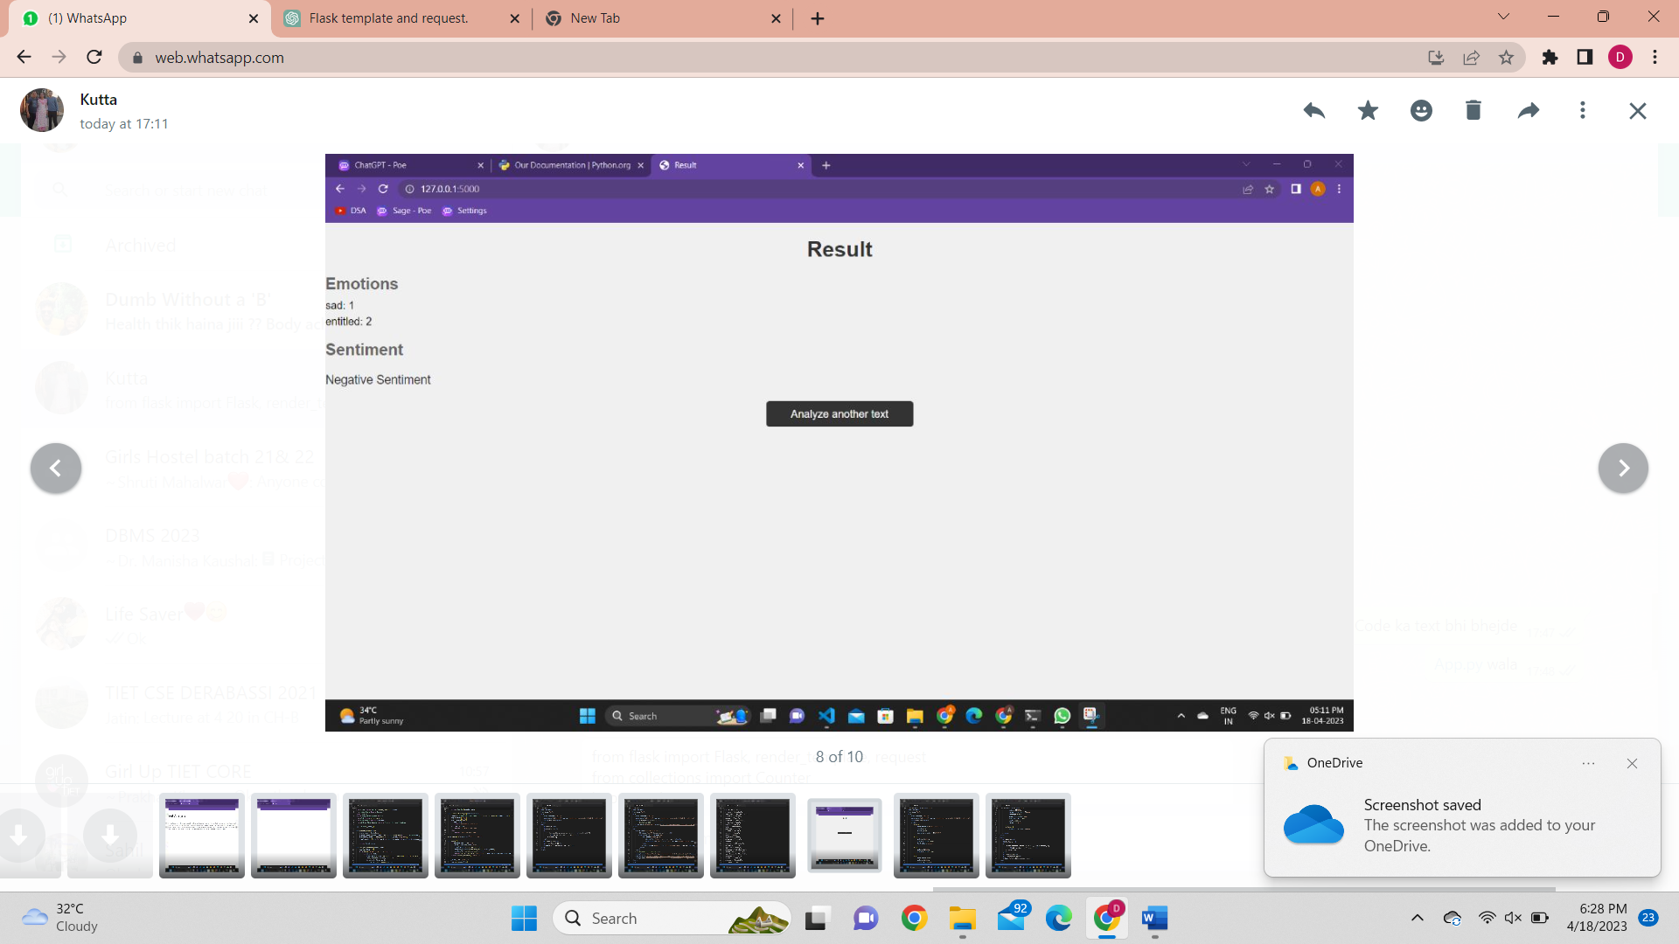

**Result:**

Sentiment analysis web applications have the potential to revolutionize the way businesses and individuals make decisions based on customer feedback and social media data. The result of a sentiment analysis web application is typically a score that represents the sentiment or attitude of the text being analyzed, ranging from highly positive to highly negative. This score can be used to identify trends and patterns in customer feedback, detect potential issues with products or services, and make data-driven decisions based on the insights gained from the analysis.

**Future scope:**

In terms of future scope, sentiment analysis web applications are likely to become even more sophisticated and accurate as natural language processing and machine learning technologies continue to evolve. These advancements will enable sentiment analysis to be performed on more diverse types of text, including social media posts, customer reviews, and news articles. Moreover, sentiment analysis can be combined with other technologies such as chatbots, voice assistants, and recommendation engines to create personalized customer experiences and automate decision-making processes. Overall, sentiment analysis web applications have a bright future ahead and are poised to play an increasingly important role in helping businesses and individuals make data-driven decisions based on customer feedback and social media data.

|  |
| --- |
|  |
|  |  |